**DAILY ONLINE ACTIVITIES SUMMARY**

|  |  |  |  |  |  |  |  |  |
| --- | --- | --- | --- | --- | --- | --- | --- | --- |
| **Date:** | **20th may,2020** | | | | | **Name:** | **Prathusha K A** | |
| **Sem & Sec** | **4th sem &b section** | | | | | **USN:** | **4AL18CS061** | |
| **Online Test Summary** | | | | | | | | |
| **Subject** | | **Object oriented concepts** | | | | | | |
| **Max. Marks** | | **30** | | **Score** | | | **18** | |
| **Certification Course Summary** | | | | | | | | |
| **Course** | **Programming for everybody (getting started with python)** | | | | | | | |
| **Certificate Provider** | | | **Coursera** | | **Duration** | | | **7 weeks** |
| **Coding Challenges** | | | | | | | | |
| **Problem Statement: Given an array a[] of size n which contains elements from 0 to n-1, write a program printDuplicates which prints the duplicate elements of the given array,If no duplicate elements is found print -1.** | | | | | | | | |
| **Status:done** | | | | | | | | |
| **Uploaded the report in Github** | | | | | **yes** | | | |
| **If yes Repository name** | | | | | **https://github.com/prathu47/lockdown-coding** | | | |
| **Uploaded the report in slack** | | | | | **yes** | | | |

Online Test Details: (Attach the snapshot and briefly write the report for the same)

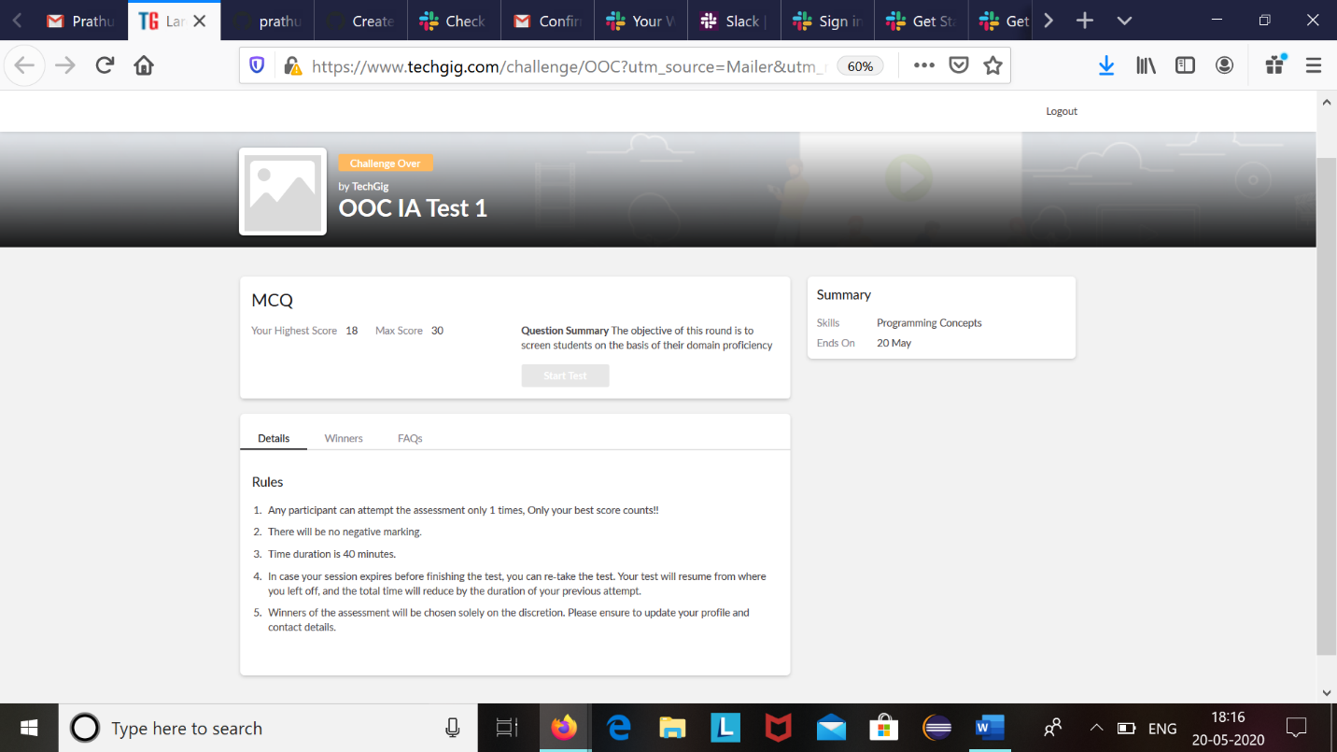

Object oriented concepts internals was conducted today.A total of 30 questions were there in which 20 of them were multiple choice questions and 10 questions were programming based questions.

The above snapshot is the result sheet which was mailed to us by the Techgig team.

Certification Course Details: (Attach the snapshot and briefly write the report for the same)

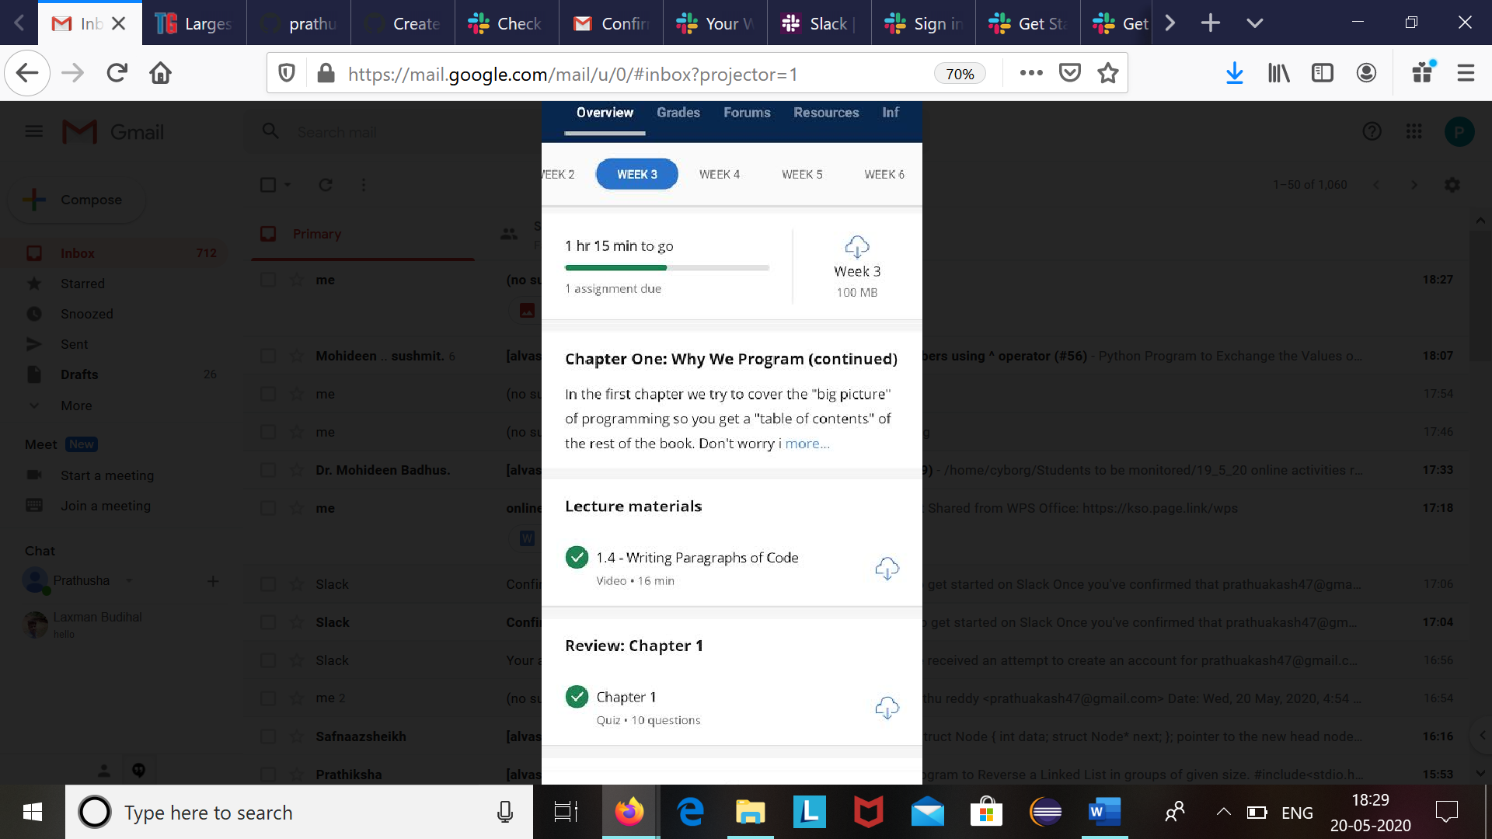

The course I have chosen during the lckdown period is programming for everybody. Since I had previously knew few topics about python iam continuing this course.Since python is gaining a lot of interest in coding platform I have preferred to choose this course.

Coding Challenges Details: (Attach the snapshot and briefly write the report for the same)

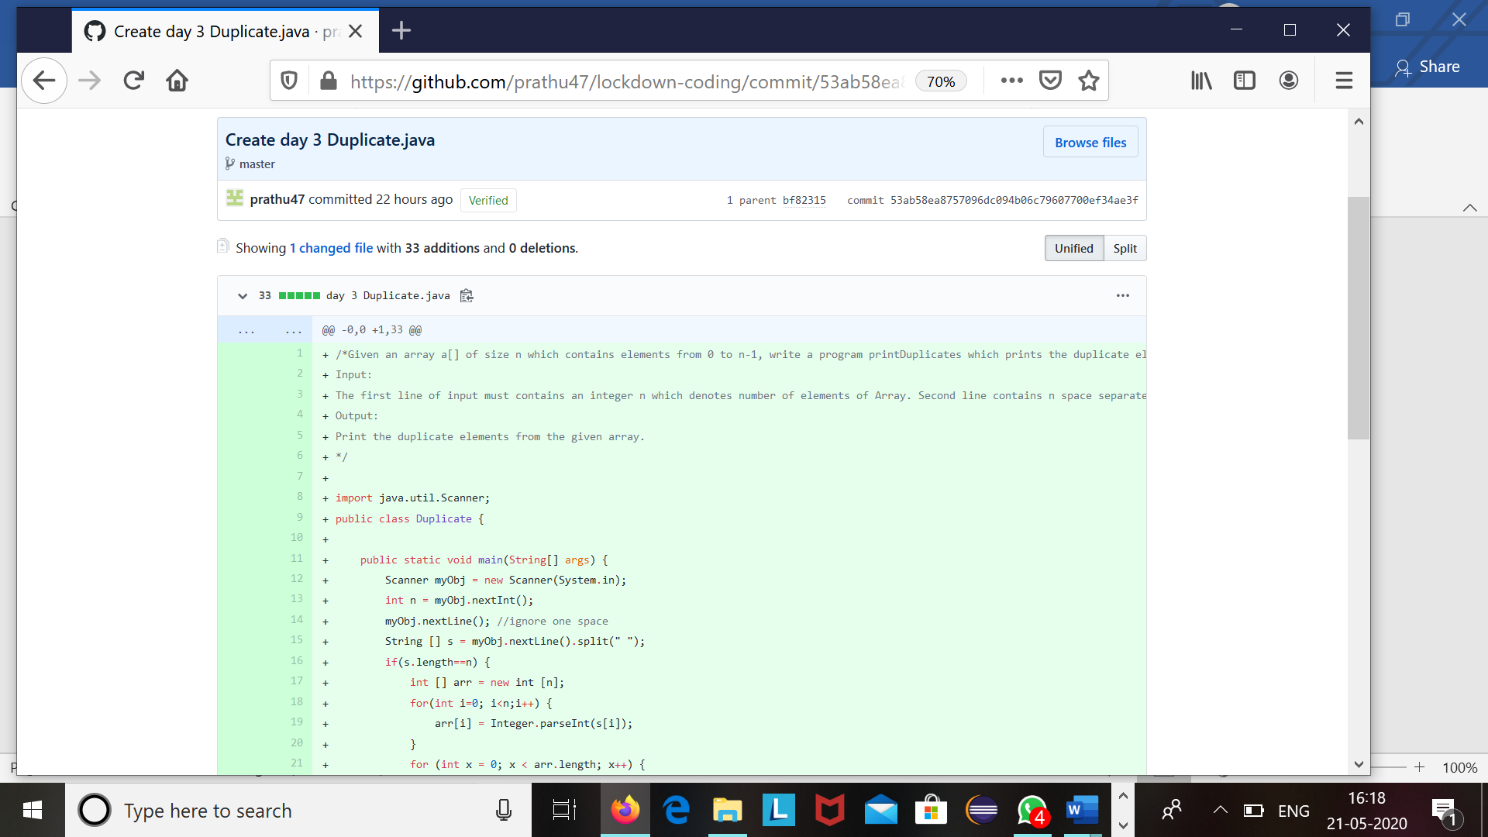

The question we had received today was :

Given an array a[] of size n which contains elements from 0 to n-1,write a program printDuplicates which prints the duplicate elements of the given array .If no duplicate element is found print -1.

Code:The above snapshot is the code which I have uploaded in my github repository.